Challenges in IOT analytics

1. Data volume
2. Problems with time - different local time, clock synchronization, day light saving
3. Problems with space - different locations, political considerations
4. Data quality
5. Analytics challenges - inaccurate data, historical data
6. Business value concerns

Benefits

1. Visibility on the entire IOT network
2. Fast identification and resolution of problems
3. Better asset utilization
4. Cost optimization
5. Expansion into new markets
6. Better customer experience
7. Improved product development

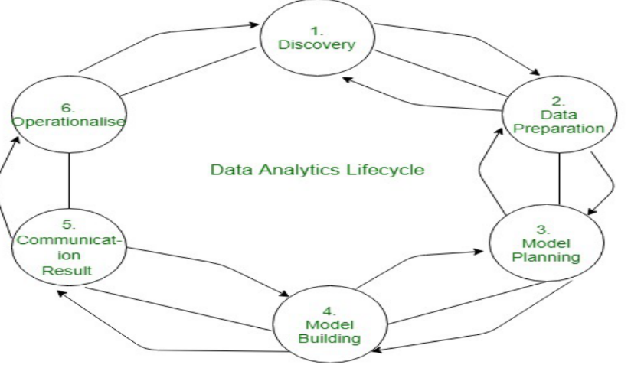

DATA ANALYTICS LIFECYCLE

Types of Data visualization

1. Comparative Plots

2. Statistical Plots

3. Topology Plots

4. Spatial Plots

Dashboarding

* Components
* KPIS
* Interactivity
* Customization
* Integration
* Sharing
* Data refresh
* Security

Strategies to organize Data for IoT Analytics

1. Linked Analytics Dataset
2. Managing Data Lakes
3. Data Retention

Types of data iot analytics

1. Descriptive
2. Diagnostic
3. Predictive analytics
4. Prescriptive

